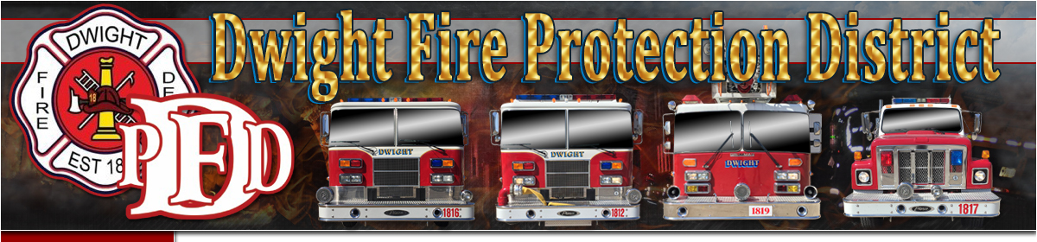

Dear Parents: Your child has requested an application to become a Fire Cadet with the Dwight Fire Protection District.

Please review the attached Operating Guideline and Parental Consent Form. If you grant permission for their membership with this Dwight Fire Protection District, please complete the consent form below and return it to the Fire Station. If you have any questions, please contact Firefighter Brandon Rivette at (815) 584-2373.

PARENTAL CONSENT FORM We have reviewed the application and operating guidelines relating to the Fire Cadet program and understand the requirements of being a Fire Cadet. We also understand our child’s performance, responsibilities and duties as a Fire Cadet with the Dwight Fire Department. We hereby give our consent to________________________________________ become a Fire Cadet with the Dwight Fire Protection District.

Parent or Guardian:_________________________________________ Date:________________

(Print Name)

Address:_________________________________________________________________________

City: ­­__________________ State:________ Zip:____________

Parent or Guardian:_____________________________________ Date:______________________

(Print Name)

Address:___________________________________________________________________

City:_______________________ State:_____________ Zip:_________________

Signatures of Parents/Guardians:

Signature:____________________________________ Relationship:___________________________

Signature:____________________________________ Relationship:____________________________